EVENT

MANAGEMENT

PROGRAM

* KASHYAP BINU
* KUSHAL B GOWDA
* HAMISH JESUDOS

# INDEX

|  |  |  |
| --- | --- | --- |
| ***S.No*** | ***Topic*** | ***Pg.no*** |
| ***1.*** | ***System Hardware and Software Specifications*** | 5 |
| ***2.*** | ***Project synopsis*** | 6 |
| ***3.*** | ***Design work*** | 8 |
| ***4.*** | ***Coding*** | 10 |
| ***5.*** | ***Output*** | 14 |

*SYSTEM SOFTWARE AND HARDWARE SPECIFICATIONS SOFTWARE*

### SOFTWARE

##### The software used to run the program are :

* *Tkinter*
* *MySQL*
* *python*

### HARDWARE

##### The hardware used to run the project are :

* + HP pavilion
  + 12GB RAM

*PROJECT SYNOPSIS*

***Aim of “EVENT MANAGEMENT PROGRAM”***

**The “EVENT MANAGEMENT PROGRAM” is a program that allows users to create and publicize their events in a platform which Is available to all. It also allows users to scout through each of the events and register for it thereby eliminating the need to visit different sites which henceforth saves time and prevents confusion of users.**

***Introduction:***

***A lot of the time , we are unaware of the events and competitions of our interest that happen around us .Finding events of your interest and then getting into the procedures of registering into it has been a late problem. This results in loss of precious oppurtunites especially for students where participations in such competitions can add to his/her portfolio which inturn is useful for future progress.***

***The ”EVENT MANAGEMENT PROGRAM” provides excellent platform to not only register/participate for events but also create events and publicize it in an open forum. This will not only help students but also institutions as they can now create events and reach more people through our platform.***

## USES OF EVENT MANAGEMENT PROGRAM:

## Helps to create an event / competition and publicize it .

## Helps people to keep track of upcoming events.

## Saves time of people as they don’t have to visit many other sites for event related queries provided the hosting institution is affiliated with our platform.

***HARDWARE USED IN EVENT MANAGEMENT PROGRAM:-***

* Display - shows the user all the information.
* Record printer
* Function key buttons
* CPU

## Software used in EVENT MANAGEMENT PROGRAM:-

***Typical platforms used in EVENT MANAGEMENT program include:***

* *Python*
* *Tkinter*
* *Microsoft operation system*

**DESIGN WORK-**

|  |  |
| --- | --- |
| **FUNCTON NAME** | **USE** |
| 1. **place FUNCTION** | Used to place a label or image or any other utility in tkinter. |
| 1. **grid FUNCTION** | Used to place a tkinter utility according to coordinates assigned. |
| 1. **pack FUNCTION** | Used to declare position of widgets with relative coordinates |
| 1. **entry FUNCTION** | Substitute of the input function used In python. Provides space for input from users. |
| 1. **button FUNCTION** | Makes a GUI button in python Tkinter . |
| 1. **execute FUNCTION** | Runs SQL statements or stored procedures from a package. |
| 1. **commit FUNCTION** | Used to permanently save the changes done in the databases. |

**EXECUTION-**

The project has been divided into 2 parts-

1. GUI- using python tkinter-

The page that we have created has been made using python tkinter through use of various widgets and functions like labels, buttons, frame , layout etc. The program GUI looks something like this-

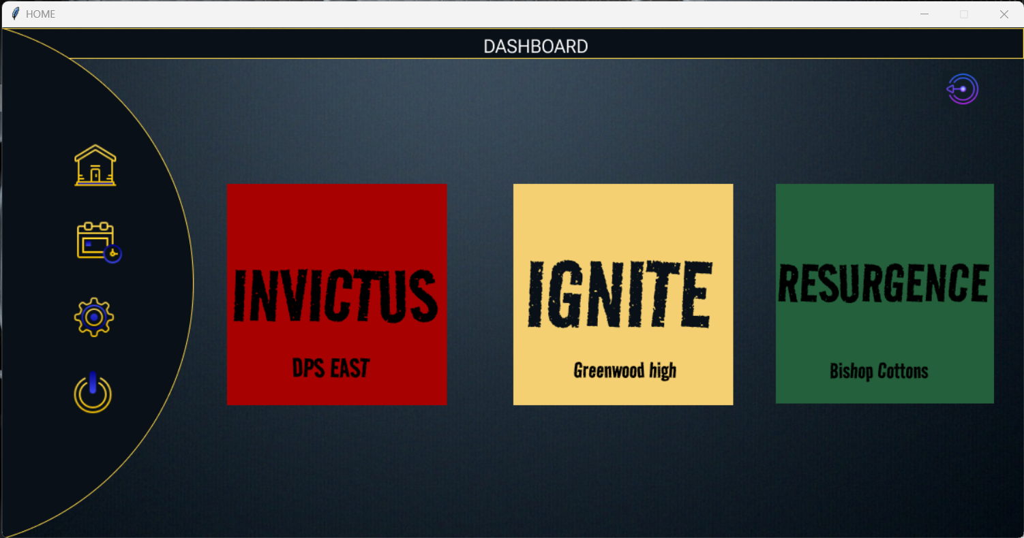

1. DATABASE- using mySQL –

The user id -password, information related to events are stored using MySQL database system.

**SOURCE CODE-**

from tkinter import *

import tkinter as tk

from PIL import ImageTk, Image

import mysql.connector as mysql

#------------SQL CONNECTION---------

mycon= mysql.connect(user='root', passwd='1234', host='localhost', db='kbg')

root=mycon.cursor()

#----------- database coding one time-------------------------

#

# root.execute("CREATE TABLE LOGIN_DATA(USERNAME VARCHAR(15) NOT NULL, PASSWORD VARCHAR(18))")

def destroy1():

window22.destroy()

def destroy():

window21.destroy()

def unregistered():

# Create the main window2

window3 = tk.Tk()

window3.configure(bg='#202A44')

window3.geometry("1200x600")

window3.title("UNREGISTRATION")

# Create the main heading label

heading_label = tk.Label(window3, text="UNREGISTERED SUCCESSFULLY", font=("Arial", 40), fg="white", bg="#202A44")

heading_label.pack()

# Set the window2 size and position on the screen

window3.geometry("1200x600")

window3.resizable(False, False)

window3.after(4000,lambda:window3.destroy())

# Run the main loop

window3.mainloop()

def registered():

# Create the main window2

window3 = tk.Tk()

window3.configure(bg='#202A44')

window3.geometry("1200x600")

window3.title("Registration Invictus")

# Create the main heading label

heading_label = tk.Label(window3, text="REGISTERED SUCCESFULLY", font=("Arial", 40), fg="white", bg="#202A44")

heading_label.pack()

# Set the window2 size and position on the screen

window3.geometry("1200x600")

window3.resizable(False, False)

window3.after(4000,lambda:window3.destroy())

# Run the main loop

window3.mainloop()

def unreg():

global window4

window22.destroy()

# Create the main window2

window4 = tk.Tk()

window4.configure(bg='#202A44')

window4.geometry("1200x600")

window4.title("Registration Resurgence")

# Create the main heading label

heading_label = tk.Label(window4, text="UNREGISTER", font=("Arial", 40), fg="white", bg="#202A44")

heading_label.pack()

# Leave 3 spaces below the heading label

# Create the event label and dropdown

event_label = tk.Label(window4, text="EVENT: ", font=("Arial", 28), fg="white", bg="#202A44")

event_label.place(x=50, y=200)

event= tk.StringVar(window4)

event_dropdown = tk.OptionMenu(window4, event, "Film Festival", "Gaming", "Stand Up Comedy", )

event_dropdown.configure(height=2, width=20)

event_dropdown.place(x=200, y=200)

# Create the event label and dropdown

org_label = tk.Label(window4, text="ORGANISER:", font=("Arial", 28), fg="white", bg="#202A44")

org_label.place(x=700, y=200)

org = tk.StringVar(window4)

org_dropdown = tk.OptionMenu(window4, org, "INVICTUS", "IGNITE", "RESURGENCE", )

org_dropdown.configure(height=2, width=20)

org_dropdown.place(x=1000, y=200)

def dell():

a="'"+str(event.get())+"'"

b=str((org.get()))

a=a.lower()

b=b.lower()

query="delete from " + b + " where event=" + a + " and name=" + "'"+user1+"'"

root.execute(query)

mycon.commit()

window4.destroy()

b6 = Button(window4, height=2, width=20,

text='UNREGISTER',

font=("RobotoRoman-SemiBold", int(15)),

borderwidth = 0,

highlightthickness = 0,

command= lambda: [f() for f in [dell(), unregistered()]],

relief = "flat")

b6.place(x=500, y=400)

window4.mainloop()

def destroy2():

window2.destroy()

def inv():

global window2

window22.destroy()

# Create the main window2

window2 = tk.Tk()

window2.configure(bg='#202A44')

window2.geometry("1200x600")

window2.title("Registration Invictus")

# Create the main heading label

heading_label = tk.Label(window2, text="Registration Invictus", font=("Arial", 40), fg="white", bg="#202A44")

heading_label.pack()

# Leave 3 spaces below the heading label

tk.Label(window2, text="", bg="#202A44").pack()

tk.Label(window2, text="", bg="#202A44").pack()

tk.Label(window2, text="", bg="#202A44").pack()

# Create a frame to hold the name and phone number fields

name_phone_frame = tk.Frame(window2, bg="#202A44")

name_phone_frame.pack()

# Create the label and text box for the name field

name_label = tk.Label(name_phone_frame, text="Name:", font=("Arial", 28), fg="white", bg="#202A44")

name_label.pack(side="left", padx=10)

name_textbox = tk.Entry(name_phone_frame, font=("Arial", 28))

name_textbox.pack(side="left")

# Create the label and text box for the phone number field

phone_label = tk.Label(name_phone_frame, text="Phone :", font=("Arial", 28), fg="white", bg="#202A44")

phone_label.pack(side="left", padx=15)

phone_textbox = tk.Entry(name_phone_frame, font=("Arial", 28))

phone_textbox.pack(side="left")

# Leave 3 spaces below the name and phone number fields

tk.Label(window2, text="", bg="#202A44").pack()

tk.Label(window2, text="", bg="#202A44").pack()

tk.Label(window2, text="", bg="#202A44").pack()

# Create a frame to hold the email and school name fields

email_school_frame = tk.Frame(window2, bg="#202A44")

email_school_frame.pack()

# Create the label and text box for the email field

email_label = tk.Label(email_school_frame, text=" Email:", font=("Arial", 28), fg="white", bg="#202A44")

email_label.pack(side="left", padx=10)

email_textbox = tk.Entry(email_school_frame, font=("Arial", 28))

email_textbox.pack(side="left")

# Create the label and text box for the school name field

school_label = tk.Label(email_school_frame, text="School :", font=("Arial", 28), fg="white", bg="#202A44")

school_label.pack(side="left", padx=10)

school_textbox = tk.Entry(email_school_frame, font=("Arial", 28))

school_textbox.pack(side="left")

# Leave 2 spaces below the email and school name fields

tk.Label(window2, text="", bg="#202A44").pack()

tk.Label(window2, text="", bg="#202A44").pack()

tk.Label(window2, text="", bg="#202A44").pack()

# Create the event label and dropdown

event_label = tk.Label(window2, text="Event:", font=("Arial", 28), fg="white", bg="#202A44")

event_label.pack()

event = tk.StringVar(window2)

event_dropdown = tk.OptionMenu(window2, event, "Film Festival", "Gaming", "Stand Up Comedy", )

event_dropdown.configure(height=1, width=7)

event_dropdown.pack()

# Leave spaces below the event dropdown

tk.Label(window2, text="", bg="#202A44").pack()

tk.Label(window2, text="", bg="#202A44").pack()

tk.Label(window2, text="", bg="#202A44").pack()

#store the user data

def data():

n=name_textbox.get()

p=str(phone_textbox.get())

e=str(email_textbox.get())

s=school_textbox.get()

ev=event.get()

query="insert into invictus values(%s, %s, %s, %s, %s, %s)"

data1=(n, p, e, s, ev, 'yes')

root.execute(query, data1)

mycon.commit()

button = tk.Button(window2, command= lambda: [f() for f in [data(), destroy2(), registered()]], text="REGISTER", font=("Arial", 20), height=1, width=10, )

# Place the button on the screen

button.pack()

def ign():

global window2

window22.destroy()

# Create the main window2

window2 = tk.Tk()

window2.configure(bg='#202A44')

window2.geometry("1200x600")

window2.title("Registration Ignite")

# Create the main heading label

heading_label = tk.Label(window2, text="Registration Ignite", font=("Arial", 40), fg="white", bg="#202A44")

heading_label.pack()

# Leave 3 spaces below the heading label

tk.Label(window2, text="", bg="#202A44").pack()

tk.Label(window2, text="", bg="#202A44").pack()

tk.Label(window2, text="", bg="#202A44").pack()

# Create a frame to hold the name and phone number fields

name_phone_frame = tk.Frame(window2, bg="#202A44")

name_phone_frame.pack()

# Create the label and text box for the name field

name_label = tk.Label(name_phone_frame, text="Name:", font=("Arial", 28), fg="white", bg="#202A44")

name_label.pack(side="left", padx=10)

name_textbox = tk.Entry(name_phone_frame, font=("Arial", 28))

name_textbox.pack(side="left")

# Create the label and text box for the phone number field

phone_label = tk.Label(name_phone_frame, text="Phone :", font=("Arial", 28), fg="white", bg="#202A44")

phone_label.pack(side="left", padx=15)

phone_textbox = tk.Entry(name_phone_frame, font=("Arial", 28))

phone_textbox.pack(side="left")

# Leave 3 spaces below the name and phone number fields

tk.Label(window2, text="", bg="#202A44").pack()

tk.Label(window2, text="", bg="#202A44").pack()

tk.Label(window2, text="", bg="#202A44").pack()

# Create a frame to hold the email and school name fields

email_school_frame = tk.Frame(window2, bg="#202A44")

email_school_frame.pack()

# Create the label and text box for the email field

email_label = tk.Label(email_school_frame, text=" Email:", font=("Arial", 28), fg="white", bg="#202A44")

email_label.pack(side="left", padx=10)

email_textbox = tk.Entry(email_school_frame, font=("Arial", 28))

email_textbox.pack(side="left")

# Create the label and text box for the school name field

school_label = tk.Label(email_school_frame, text="School :", font=("Arial", 28), fg="white", bg="#202A44")

school_label.pack(side="left", padx=10)

school_textbox = tk.Entry(email_school_frame, font=("Arial", 28))

school_textbox.pack(side="left")

# Leave 2 spaces below the email and school name fields

tk.Label(window2, text="", bg="#202A44").pack()

tk.Label(window2, text="", bg="#202A44").pack()

tk.Label(window2, text="", bg="#202A44").pack()

# Create the event label and dropdown

event_label = tk.Label(window2, text="Event:", font=("Arial", 28), fg="white", bg="#202A44")

event_label.pack()

event = tk.StringVar(window2)

event_dropdown = tk.OptionMenu(window2, event, "Film Festival", "Gaming", "Stand Up Comedy", )

event_dropdown.configure(height=1, width=7)

event_dropdown.pack()

# Leave spaces below the event dropdown

tk.Label(window2, text="", bg="#202A44").pack()

tk.Label(window2, text="", bg="#202A44").pack()

tk.Label(window2, text="", bg="#202A44").pack()

#store the user data

def data():

n=name_textbox.get()

p=str(phone_textbox.get())

e=str(email_textbox.get())

s=school_textbox.get()

ev=event.get()

query="insert into ignite values(%s, %s, %s, %s, %s, %s)"

data1=(n, p, e, s, ev, 'yes')

root.execute(query, data1)

mycon.commit()

button = tk.Button(window2, command= lambda: [f() for f in [data(), destroy2(), registered()]], text="REGISTER", font=("Arial", 20), height=1, width=10, )

# Place the button on the screen

button.pack()

# Set the window2 size and position on the screen

window2.geometry("1200x600")

window2.resizable(False, False)

# Run the main loop

window2.mainloop()

def resur():

global window2

window22.destroy()

# Create the main window2

window2 = tk.Tk()

window2.configure(bg='#202A44')

window2.geometry("1200x600")

window2.title("Registration Resurgence")

# Create the main heading label

heading_label = tk.Label(window2, text="Registration Resurgence", font=("Arial", 40), fg="white", bg="#202A44")

heading_label.pack()

# Leave 3 spaces below the heading label

tk.Label(window2, text="", bg="#202A44").pack()

tk.Label(window2, text="", bg="#202A44").pack()

tk.Label(window2, text="", bg="#202A44").pack()

# Create a frame to hold the name and phone number fields

name_phone_frame = tk.Frame(window2, bg="#202A44")

name_phone_frame.pack()

# Create the label and text box for the name field

name_label = tk.Label(name_phone_frame, text="Name:", font=("Arial", 28), fg="white", bg="#202A44")

name_label.pack(side="left", padx=10)

name_textbox = tk.Entry(name_phone_frame, font=("Arial", 28))

name_textbox.pack(side="left")

# Create the label and text box for the phone number field

phone_label = tk.Label(name_phone_frame, text="Phone :", font=("Arial", 28), fg="white", bg="#202A44")

phone_label.pack(side="left", padx=15)

phone_textbox = tk.Entry(name_phone_frame, font=("Arial", 28))

phone_textbox.pack(side="left")

# Leave 3 spaces below the name and phone number fields

tk.Label(window2, text="", bg="#202A44").pack()

tk.Label(window2, text="", bg="#202A44").pack()

tk.Label(window2, text="", bg="#202A44").pack()

# Create a frame to hold the email and school name fields

email_school_frame = tk.Frame(window2, bg="#202A44")

email_school_frame.pack()

# Create the label and text box for the email field

email_label = tk.Label(email_school_frame, text=" Email:", font=("Arial", 28), fg="white", bg="#202A44")

email_label.pack(side="left", padx=10)

email_textbox = tk.Entry(email_school_frame, font=("Arial", 28))

email_textbox.pack(side="left")

# Create the label and text box for the school name field

school_label = tk.Label(email_school_frame, text="School :", font=("Arial", 28), fg="white", bg="#202A44")

school_label.pack(side="left", padx=10)

school_textbox = tk.Entry(email_school_frame, font=("Arial", 28))

school_textbox.pack(side="left")

# Leave 2 spaces below the email and school name fields

tk.Label(window2, text="", bg="#202A44").pack()

tk.Label(window2, text="", bg="#202A44").pack()

tk.Label(window2, text="", bg="#202A44").pack()

# Create the event label and dropdown

event_label = tk.Label(window2, text="Event:", font=("Arial", 28), fg="white", bg="#202A44")

event_label.pack()

event = tk.StringVar(window2)

event_dropdown = tk.OptionMenu(window2, event, "Film Festival", "Gaming", "Stand Up Comedy", )

event_dropdown.configure(height=1, width=7)

event_dropdown.pack()

# Leave spaces below the event dropdown

tk.Label(window2, text="", bg="#202A44").pack()

tk.Label(window2, text="", bg="#202A44").pack()

tk.Label(window2, text="", bg="#202A44").pack()

#store the user data

def data():

n=name_textbox.get()

p=str(phone_textbox.get())

e=str(email_textbox.get())

s=school_textbox.get()

ev=event.get()

query="insert into resurg values(%s, %s, %s, %s, %s, %s)"

data1=(n, p, e, s, ev, 'yes')

root.execute(query, data1)

mycon.commit()

button = tk.Button(window2, command= lambda: [f() for f in [data(), destroy2(), registered()]], text="REGISTER", font=("Arial", 20), height=1, width=10, )

# Place the button on the screen

button.pack()

# Set the window2 size and position on the screen

window2.geometry("1200x600")

window2.resizable(False, False)

# Run the main loop

window2.mainloop()

def calendar():

global window22

window22=tk.Toplevel()

window22.geometry("1200x600")

window22.configure(bg = "#ffffff")

window22.title("about")

canvas = Canvas(

window22,

bg = "#ffffff",

height = 600,

width = 1200,

bd = 0,

highlightthickness = 0,

relief = "ridge")

canvas.place(x = 0, y = 0)

background_img = PhotoImage(file = f"calendar.png")

background = canvas.create_image(

545.0, 400.5,

image=background_img)

img0 = PhotoImage(file = f"img0.png")

b0 = Button(window22,

image = img0,

borderwidth = 0,

command=lambda: [f() for f in [destroy(), page()]],

highlightthickness = 0,

relief = "flat")

b0.place(

x = 1104, y = 51,

width = 44,

height = 42)

img1 = PhotoImage(file = f"img1.png")

b1 = Button(window22,

image = img1,

borderwidth = 0,

bg='#091017',

command=destroy1,

highlightthickness = 0,

relief = "flat")

b1.place(

x = 82, y = 132,

width = 55,

height = 60)

img2 = PhotoImage(file = f"img2.png")

b2 = Button(window22,

image = img2,

borderwidth = 0,

bg='#091017',

highlightthickness = 0,

command=lambda: [f() for f in [destroy1(), calendar()]],

relief = "flat")

b2.place(

x = 82, y = 221,

width = 65,

height = 64)

img3 = PhotoImage(file = f"img3.png")

b3 = Button(window22,

image = img3,

borderwidth = 0,

bg='#091017',

highlightthickness = 0,

command=lambda: [f() for f in [destroy1(), settings()]],

relief = "flat")

b3.place(

x = 82, y = 314,

width = 52,

height = 55)

img4 = PhotoImage(file = f"img4.png")

b4 = Button(window22,

image = img4,

borderwidth = 0,

bg='#091017',

command=destroy,

highlightthickness = 0,

relief = "flat")

b4.place(

x = 79, y = 398,

width = 55,

height = 61)

query= "select * from invictus where name=%s"

query1= "select * from ignite where name=%s"

query2= "select * from resurg where name=%s"

name=user1,

a=root.execute(query, name)

b=''

b1=''

b2=''

for i in root:

b+= i[4] + ", "

a=root.execute(query1, name)

for i in root:

b1+=i[4]+ ", "

a=root.execute(query2, name)

for i in root:

b2+=i[4]+ ", "

if user1=='kbg':

query3= "select * from invictus"

data=''

root.execute(query3)

for i in root:

i=str(i)+'\n'

data+=i

canvas.create_text(

630.0, 300.5,

text = "STUDENTS REGISTERED FOR INVICTUS:\n"+"(Name, Phoneno, Email, School, Event, Status)"+ data,

fill = "#000000",

font = ("RobotoRoman-SemiBold", int(15.0)))

else:

label1=Label(window22, width=50, height=9, bg='#00f0ff',

text = "INVICTUS: "+ b +'\n\n\n\n'+ "IGNITE: "+ b1 + '\n\n\n\n'+ "RESURGENCE:" +b2 +"",

font = ("RobotoRoman-SemiBold", int(20.0)))

label1.place(x=300.0, y=200.5,)

b6 = Button(window22,

text='UNREGISTER',

font=("RobotoRoman-SemiBold", int(15)),

borderwidth = 0,

highlightthickness = 0,

command= unreg,

relief = "flat")

b6.place(

x = 580, y = 550,

width = 220,

height = 47)

window22.resizable(False, False)

window22.mainloop()

def about():

global window22

window22=tk.Toplevel()

window22.geometry("1200x600")

window22.configure(bg = "#ffffff")

window22.title("about")

canvas = Canvas(

window22,

bg = "#ffffff",

height = 600,

width = 1200,

bd = 0,

highlightthickness = 0,

relief = "ridge")

canvas.place(x = 0, y = 0)

background_img = PhotoImage(file = f"about.png")

background = canvas.create_image(

545.0, 400.5,

image=background_img)

img0 = PhotoImage(file = f"img0.png")

b0 = Button(window22,

image = img0,

borderwidth = 0,

command=lambda: [f() for f in [destroy(), page()]],

highlightthickness = 0,

relief = "flat")

b0.place(

x = 1104, y = 51,

width = 44,

height = 42)

img1 = PhotoImage(file = f"img1.png")

b1 = Button(window22,

image = img1,

borderwidth = 0,

bg='#091017',

command=destroy1,

highlightthickness = 0,

relief = "flat")

b1.place(

x = 82, y = 132,

width = 55,

height = 60)

img2 = PhotoImage(file = f"img2.png")

b2 = Button(window22,

image = img2,

borderwidth = 0,

bg='#091017',

highlightthickness = 0,

command=lambda: [f() for f in [destroy1(), calendar()]],

relief = "flat")

b2.place(

x = 82, y = 221,

width = 65,

height = 64)

img3 = PhotoImage(file = f"img3.png")

b3 = Button(window22,

image = img3,

borderwidth = 0,

bg='#091017',

highlightthickness = 0,

command=lambda: [f() for f in [destroy1(), settings()]],

relief = "flat")

b3.place(

x = 82, y = 314,

width = 52,

height = 55)

img4 = PhotoImage(file = f"img4.png")

b4 = Button(window22,

image = img4,

borderwidth = 0,

bg='#091017',

command=destroy,

highlightthickness = 0,

relief = "flat")

b4.place(

x = 79, y = 398,

width = 55,

height = 61)

window22.resizable(False, False)

window22.mainloop()

def support():

destroy1()

global window22

window22=tk.Toplevel()

window22.geometry("1200x600")

window22.configure(bg = "#ffffff")

window22.title("support")

canvas = Canvas(

window22,

bg = "#ffffff",

height = 600,

width = 1200,

bd = 0,

highlightthickness = 0,

relief = "ridge")

canvas.place(x = 0, y = 0)

background_img = PhotoImage(file = f"support.png")

background = canvas.create_image(

545.0, 400.5,

image=background_img)

img0 = PhotoImage(file = f"img0.png")

b0 = Button(window22,

image = img0,

borderwidth = 0,

command=lambda: [f() for f in [destroy(), page()]],

highlightthickness = 0,

relief = "flat")

b0.place(

x = 1104, y = 51,

width = 44,

height = 42)

img1 = PhotoImage(file = f"img1.png")

b1 = Button(window22,

image = img1,

borderwidth = 0,

bg='#091017',

command=destroy1,

highlightthickness = 0,

relief = "flat")

b1.place(

x = 82, y = 132,

width = 55,

height = 60)

img2 = PhotoImage(file = f"img2.png")

b2 = Button(window22,

image = img2,

borderwidth = 0,

bg='#091017',

highlightthickness = 0,

command=lambda: [f() for f in [destroy1(), calendar()]],

relief = "flat")

b2.place(

x = 82, y = 221,

width = 65,

height = 64)

img3 = PhotoImage(file = f"img3.png")

b3 = Button(window22,

image = img3,

borderwidth = 0,

bg='#091017',

highlightthickness = 0,

command=lambda: [f() for f in [destroy1(), settings()]],

relief = "flat")

b3.place(

x = 82, y = 314,

width = 52,

height = 55)

img4 = PhotoImage(file = f"img4.png")

b4 = Button(window22,

image = img4,

borderwidth = 0,

bg='#091017',

command=destroy,

highlightthickness = 0,

relief = "flat")

b4.place(

x = 79, y = 398,

width = 55,

height = 61)

window22.resizable(False, False)

window22.mainloop()

def settings():

global window22

window22=tk.Toplevel()

window22.geometry("1200x600")

window22.configure(bg = "#ffffff")

window22.title("settings")

canvas = Canvas(

window22,

bg = "#ffffff",

height = 600,

width = 1200,

bd = 0,

highlightthickness = 0,

relief = "ridge")

canvas.place(x = 0, y = 0)

background_img = PhotoImage(file = f"settings.png")

background = canvas.create_image(

545.0, 400.5,

image=background_img)

img0 = PhotoImage(file = f"img0.png")

b0 = Button(window22,

image = img0,

borderwidth = 0,

command=lambda: [f() for f in [destroy(), page()]],

highlightthickness = 0,

relief = "flat")

b0.place(

x = 1104, y = 51,

width = 44,

height = 42)

img1 = PhotoImage(file = f"img1.png")

b1 = Button(window22,

image = img1,

borderwidth = 0,

bg='#091017',

command=destroy1

,

highlightthickness = 0,

relief = "flat")

b1.place(

x = 82, y = 132,

width = 55,

height = 60)

img2 = PhotoImage(file = f"img2.png")

b2 = Button(window22,

image = img2,

borderwidth = 0,

bg='#091017',

highlightthickness = 0,

command=lambda: [f() for f in [destroy1(), calendar()]],

relief = "flat")

b2.place(

x = 82, y = 221,

width = 65,

height = 64)

img3 = PhotoImage(file = f"img3.png")

b3 = Button(window22,

image = img3,

borderwidth = 0,

bg='#091017',

highlightthickness = 0,

command=lambda: [f() for f in [destroy1(), settings()]],

relief = "flat")

b3.place(

x = 82, y = 314,

width = 52,

height = 55)

img4 = PhotoImage(file = f"img4.png")

b4 = Button(window22,

image = img4,

borderwidth = 0,

bg='#091017',

command=destroy,

highlightthickness = 0,

relief = "flat")

b4.place(

x = 79, y = 398,

width = 55,

height = 61)

img5 = PhotoImage(file = f"im5.png")

b5 = Button(window22,

image = img5,

borderwidth = 0,

highlightthickness = 0,

command=lambda: [f() for f in [destroy1(), about()]],

relief = "flat")

b5.place(

x = 336, y = 224,

width = 650,

height = 82)

img6 = PhotoImage(file = f"im6.png")

b6 = Button(window22,

image = img6,

borderwidth = 0,

command=lambda: [f() for f in [destroy1(), support()]],

highlightthickness = 0,

relief = "flat")

b6.place(

x = 336, y = 132,

width = 650,

height = 82)

window22.resizable(False, False)

window22.mainloop()

def invictus():

global window22

window22=tk.Toplevel()

window22.geometry("1200x600")

window22.configure(bg = "#ffffff")

window22.title("invctus")

canvas = Canvas(

window22,

bg = "#ffffff",

height = 600,

width = 1200,

bd = 0,

highlightthickness = 0,

relief = "ridge")

canvas.place(x = 0, y = 0)

background_img = PhotoImage(file = f"invitus.png")

background = canvas.create_image(

545.0, 400.5,

image=background_img)

img0 = PhotoImage(file = f"img0.png")

b0 = Button(window22,

image = img0,

borderwidth = 0,

command=lambda: [f() for f in [destroy(), page()]],

highlightthickness = 0,

relief = "flat")

b0.place(

x = 1104, y = 51,

width = 44,

height = 42)

img1 = PhotoImage(file = f"img1.png")

b1 = Button(window22,

image = img1,

borderwidth = 0,

bg='#091017',

command=destroy1

,

highlightthickness = 0,

relief = "flat")

b1.place(

x = 82, y = 132,

width = 55,

height = 60)

img2 = PhotoImage(file = f"img2.png")

b2 = Button(window22,

image = img2,

borderwidth = 0,

bg='#091017',

highlightthickness = 0,

command=lambda: [f() for f in [destroy1(), calendar()]],

relief = "flat")

b2.place(

x = 82, y = 221,

width = 65,

height = 64)

img3 = PhotoImage(file = f"img3.png")

b3 = Button(window22,

image = img3,

borderwidth = 0,

bg='#091017',

highlightthickness = 0,

command=lambda: [f() for f in [destroy1(), settings()]],

relief = "flat")

b3.place(

x = 82, y = 314,

width = 52,

height = 55)

img4 = PhotoImage(file = f"img4.png")

b4 = Button(window22,

image = img4,

borderwidth = 0,

bg='#091017',

command=destroy,

highlightthickness = 0,

relief = "flat")

b4.place(

x = 79, y = 398,

width = 55,

height = 61)

img5 = PhotoImage(file = f"register.png")

b5 = Button(window22,

image = img5,

borderwidth = 0,

command=inv,

highlightthickness = 0,

relief = "flat")

b5.place(

x = 550, y = 530,

width = 220,

height = 47)

window22.resizable(False, False)

window22.mainloop()

def ignite():

global window22

window22=tk.Toplevel()

window22.geometry("1200x600")

window22.configure(bg = "#ffffff")

window22.title("ignite")

canvas = Canvas(

window22,

bg = "#ffffff",

height = 600,

width = 1200,

bd = 0,

highlightthickness = 0,

relief = "ridge")

canvas.place(x = 0, y = 0)

background_img = PhotoImage(file = f"ignite.png")

background = canvas.create_image(

545.0, 400.5,

image=background_img)

img0 = PhotoImage(file = f"img0.png")

b0 = Button(window22,

image = img0,

borderwidth = 0,

highlightthickness = 0,

command=lambda: [f() for f in [destroy(), page()]],

relief = "flat")

b0.place(

x = 1104, y = 51,

width = 44,

height = 42)

img1 = PhotoImage(file = f"img1.png")

b1 = Button(window22,

image = img1,

borderwidth = 0,

bg='#091017',

command=destroy1,

highlightthickness = 0,

relief = "flat")

b1.place(

x = 82, y = 132,

width = 55,

height = 60)

img2 = PhotoImage(file = f"img2.png")

b2 = Button(window22,

image = img2,

borderwidth = 0,

bg='#091017',

highlightthickness = 0,

command=lambda: [f() for f in [destroy1(), calendar()]],

relief = "flat")

b2.place(

x = 82, y = 221,

width = 65,

height = 64)

img3 = PhotoImage(file = f"img3.png")

b3 = Button(window22,

image = img3,

borderwidth = 0,

bg='#091017',

highlightthickness = 0,

command=lambda: [f() for f in [destroy1(), settings()]],

relief = "flat")

b3.place(

x = 82, y = 314,

width = 52,

height = 55)

img4 = PhotoImage(file = f"img4.png")

b4 = Button(window22,

image = img4,

borderwidth = 0,

bg='#091017',

command=destroy,

highlightthickness = 0,

relief = "flat")

b4.place(

x = 79, y = 398,

width = 55,

height = 61)

img5 = PhotoImage(file = f"register.png")

b5 = Button(window22,

image = img5,

borderwidth = 0,

highlightthickness = 0,

command= ign,

relief = "flat")

b5.place(

x = 550, y = 530,

width = 220,

height = 47)

window22.resizable(False, False)

window22.mainloop()

def resurg():

global window22

window22=tk.Toplevel()

window22.geometry("1200x600")

window22.configure(bg = "#ffffff")

window22.title("resurg")

canvas = Canvas(

window22,

bg = "#ffffff",

height = 600,

width = 1200,

bd = 0,

highlightthickness = 0,

relief = "ridge")

canvas.place(x = 0, y = 0)

background_img = PhotoImage(file = f"resurgence.png")

background = canvas.create_image(

545.0, 400.5,

image=background_img)

img0 = PhotoImage(file = f"img0.png")

b0 = Button(window22,

image = img0,

borderwidth = 0,

command=lambda: [f() for f in [destroy(), page()]],

highlightthickness = 0,

relief = "flat")

b0.place(

x = 1104, y = 51,

width = 44,

height = 42)

img1 = PhotoImage(file = f"img1.png")

b1 = Button(window22,

image = img1,

borderwidth = 0,

bg='#091017',

command=destroy1

,

highlightthickness = 0,

relief = "flat")

b1.place(

x = 82, y = 132,

width = 55,

height = 60)

img2 = PhotoImage(file = f"img2.png")

b2 = Button(window22,

image = img2,

borderwidth = 0,

bg='#091017',

highlightthickness = 0,

command=lambda: [f() for f in [destroy1(), calendar()]],

relief = "flat")

b2.place(

x = 82, y = 221,

width = 65,

height = 64)

img3 = PhotoImage(file = f"img3.png")

b3 = Button(window22,

image = img3,

borderwidth = 0,

bg='#091017',

highlightthickness = 0,

command=lambda: [f() for f in [destroy1(), settings()]],

relief = "flat")

b3.place(

x = 82, y = 314,

width = 52,

height = 55)

img4 = PhotoImage(file = f"img4.png")

b4 = Button(window22,

image = img4,

borderwidth = 0,

bg='#091017',

command=destroy,

highlightthickness = 0,

relief = "flat")

b4.place(

x = 79, y = 398,

width = 55,

height = 61)

img5 = PhotoImage(file = f"register.png")

b5 = Button(window22,

image = img5,

borderwidth = 0,

highlightthickness = 0,

command= resur,

relief = "flat")

b5.place(

x = 550, y = 530,

width = 220,

height = 47)

window22.resizable(False, False)

window22.mainloop()

def home():

global window21

window21=Tk()

window21.geometry("1200x600")

window21.configure(bg = "#ffffff")

window21.title("HOME")

canvas = Canvas(

window21,

bg = "#ffffff",

height = 600,

width = 1200,

bd = 0,

highlightthickness = 0,

relief = "ridge")

canvas.place(x = 0, y = 0)

background_img = PhotoImage(file = f"background.png")

background = canvas.create_image(

545.0, 400.5,

image=background_img)

img0 = PhotoImage(file = f"img0.png")

b0 = Button(window21,

image = img0,

borderwidth = 0,

highlightthickness = 0,

command=lambda: [f() for f in [destroy(), page()]],

relief = "flat")

b0.place(

x = 1104, y = 51,

width = 44,

height = 42)

img1 = PhotoImage(file = f"img1.png")

b1 = Button(window21,

image = img1,

borderwidth = 0,

bg='#091017',

highlightthickness = 0,

relief = "flat")

b1.place(

x = 82, y = 132,

width = 55,

height = 60)

img2 = PhotoImage(file = f"img2.png")

b2 = Button(window21,

image = img2,

borderwidth = 0,

bg='#091017',

highlightthickness = 0,

command=calendar,

relief = "flat")

b2.place(

x = 82, y = 221,

width = 65,

height = 64)

img3 = PhotoImage(file = f"img3.png")

b3 = Button(window21,

image = img3,

borderwidth = 0,

bg='#091017',

highlightthickness = 0,

command=settings,

relief = "flat")

b3.place(

x = 82, y = 314,

width = 52,

height = 55)

img4 = PhotoImage(file = f"img4.png")

b4 = Button(window21,

image = img4,

borderwidth = 0,

bg='#091017',

highlightthickness = 0,

command=destroy,

relief = "flat")

b4.place(

x = 79, y = 398,

width = 55,

height = 61)

img5 = PhotoImage(file = f"img5.png")

b5 = Button(window21,

image = img5,

borderwidth = 0,

highlightthickness = 0,

command = ignite,

relief = "flat")

b5.place(

x = 600, y = 184,

width = 258,

height = 260)

img6 = PhotoImage(file = f"img6.png")

b6 = Button(window21,

image = img6,

borderwidth = 0,

highlightthickness = 0,

command = resurg,

relief = "flat")

b6.place(

x = 908, y = 184,

width = 256,

height = 258)

img7 = PhotoImage(file = f"img7.png")

b7 = Button(window21,

image = img7,

borderwidth = 0,

highlightthickness = 0,

command = invictus,

relief = "flat")

b7.place(

x = 264, y = 184,

width = 258,

height = 260)

window21.resizable(False, False)

window21.mainloop()

#------singup window23 programmming----------------------

def sign_up():

class LoginPage:

def __init__(self, window23):

self.window23 = window23

self.window23.geometry('1366x768')

self.window23.resizable(0, 0)

# self.window23.state('zoomed')

self.window23.title('Login Page')

# ========================================================================

# ============================background image============================

# ========================================================================

self.bg_frame = Image.open('background1.png')

photo = ImageTk.PhotoImage(self.bg_frame,master=self.window23)

self.bg_panel = Label(self.window23, image=photo)

self.bg_panel.image = photo

self.bg_panel.pack(fill='both', expand='yes')

# ====== Login Frame =========================

self.lgn_frame = Frame(self.window23, bg='#040405', width=950, height=600)

self.lgn_frame.place(x=200, y=70)

# ========================================================================

# ========================================================

# ========================================================================

self.txt = "SIGN UP"

self.heading = Label(self.lgn_frame, text=self.txt, font=('yu gothic ui', 25, "bold"), bg="#040405",

fg='white',

bd=5,

relief=FLAT)

self.heading.place(x=80, y=30, width=600, height=30)

# ========================================================================

# ============ Left Side Image ================================================

# ========================================================================

self.side_image = Image.open('vector.png')

photo = ImageTk.PhotoImage(self.side_image, master=self.window23)

self.side_image_label = Label(self.lgn_frame, image=photo, bg='#040405')

self.side_image_label.image = photo

self.side_image_label.place(x=5, y=100)

# ========================================================================

# ============ Sign UP Image =============================================

# ========================================================================

self.sign_in_image = Image.open('hyy.png')

photo = ImageTk.PhotoImage(self.sign_in_image, master=self.window23)

self.sign_in_image_label = Label(self.lgn_frame, image=photo, bg='#040405')

self.sign_in_image_label.image = photo

self.sign_in_image_label.place(x=620, y=130)

# ========================================================================

# ============ Sign UP label =============================================

# ========================================================================

self.sign_in_label = Label(self.lgn_frame, text="Sign up", bg="#040405", fg="white",

font=("yu gothic ui", 17, "bold"))

self.sign_in_label.place(x=650, y=240)

# ========================================================================

# ============================username====================================

# ========================================================================

self.username_label = Label(self.lgn_frame, text="Username", bg="#040405", fg="#4f4e4d",

font=("yu gothic ui", 13, "bold"))

self.username_label.place(x=550, y=300)

self.username_entry = Entry(self.lgn_frame, highlightthickness=0, relief=FLAT, bg="#040405", fg="#6b6a69",

font=("yu gothic ui ", 12, "bold"))

self.username_entry.place(x=580, y=335, width=270)

self.username_line = Canvas(self.lgn_frame, width=300, height=2.0, bg="#bdb9b1", highlightthickness=0)

self.username_line.place(x=550, y=359)

# ===== Username icon =========

self.username_icon = Image.open('username_icon.png')

photo = ImageTk.PhotoImage(self.username_icon, master=self.window23)

self.username_icon_label = Label(self.lgn_frame, image=photo, bg='#040405')

self.username_icon_label.image = photo

self.username_icon_label.place(x=550, y=332)

# ========================================================================

# ============================password====================================

# ========================================================================

self.password_label = Label(self.lgn_frame, text="new Password", bg="#040405", fg="#4f4e4d",

font=("yu gothic ui", 13, "bold"))

self.password_label.place(x=550, y=380)

self.password_entry = Entry(self.lgn_frame, highlightthickness=0, relief=FLAT, bg="#040405", fg="#6b6a69",

font=("yu gothic ui", 12, "bold"), show="*")

self.password_entry.place(x=580, y=416, width=244)

self.password_line = Canvas(self.lgn_frame, width=300, height=2.0, bg="#bdb9b1", highlightthickness=0)

self.password_line.place(x=550, y=440)

# ======== Password icon ================

self.password_icon = Image.open('password_icon.png')

photo = ImageTk.PhotoImage(self.password_icon, master=self.window23)

self.password_icon_label = Label(self.lgn_frame, image=photo, bg='#040405')

self.password_icon_label.image = photo

self.password_icon_label.place(x=550, y=414)

# ========================================================================

# ============================confirm password====================================

# ========================================================================

self.password_label = Label(self.lgn_frame, text="confirm Password", bg="#040405", fg="#4f4e4d",

font=("yu gothic ui", 13, "bold"))

self.password_label.place(x=550, y=450)

self.password_entry = Entry(self.lgn_frame, highlightthickness=0, relief=FLAT, bg="#040405", fg="#6b6a69",

font=("yu gothic ui", 12, "bold"), show="*")

self.password_entry.place(x=580, y=490, width=244)

self.password_line = Canvas(self.lgn_frame, width=300, height=2.0, bg="#bdb9b1", highlightthickness=0)

self.password_line.place(x=550, y=510)

# ======== Password icon ================

self.password_icon = Image.open('password_icon.png')

photo = ImageTk.PhotoImage(self.password_icon, master=self.window23)

self.password_icon_label = Label(self.lgn_frame, image=photo, bg='#040405')

self.password_icon_label.image = photo

self.password_icon_label.place(x=550, y=483)

def user1():

user2=str(self.username_entry.get())

pass2=str(self.password_entry.get())

pass3= self.password_entry.get()

if pass2==pass3:

q=("INSERT INTO LOGIN_DATA VALUES(%s, %s)")

d=(user2, pass2)

root.execute(q, d)

print("succesfully created now login")

window23.destroy()

else:

print("passwords do not match")

mycon.commit()

# ========================================================================

# ============================sign button================================

# ========================================================================

self.lgn_button = Image.open('btn1.png')

photo = ImageTk.PhotoImage(self.lgn_button, master=self.window23)

self.lgn_button_label = Label(self.lgn_frame, image=photo, bg='#040405')

self.lgn_button_label.image = photo

self.lgn_button_label.place(x=550, y=530)

self.login = Button(self.lgn_button_label, text='SIGN UP', font=("yu gothic ui", 13, "bold"), width=25, bd=0,

bg='#3047ff', cursor='hand2',command=user1, activebackground='#3047ff', fg='white')

self.login.place(x=20, y=10)

# ========= show/hide password 1==================================================================

self.show_image = ImageTk.PhotoImage \

(file='show.png', master=self.window23)

self.hide_image = ImageTk.PhotoImage \

(file='hide.png', master=self.window23)

self.show_button = Button(self.lgn_frame, image=self.show_image, command=self.show, relief=FLAT,

activebackground="white"

, borderwidth=0, background="white", cursor="hand2")

self.show_button.place(x=860, y=420)

def show(self):

self.hide_button = Button(self.lgn_frame, image=self.hide_image, command=self.hide, relief=FLAT,

activebackground="white"

, borderwidth=0, background="white", cursor="hand2")

self.hide_button.place(x=860, y=420)

self.password_entry.config(show='')

def hide(self):

self.show_button = Button(self.lgn_frame, image=self.show_image, command=self.show, relief=FLAT,

activebackground="white"

, borderwidth=0, background="white", cursor="hand2")

self.show_button.place(x=860, y=420)

self.password_entry.config(show='*')

# ========= show/hide password 2==================================================================

self.show_image = ImageTk.PhotoImage \

(file='show.png')

self.hide_image = ImageTk.PhotoImage \

(file='hide.png')

self.show_button = Button(self.lgn_frame, image=self.show_image, command=self.show, relief=FLAT,

activebackground="white"

, borderwidth=0, background="white", cursor="hand2")

self.show_button.place(x=860, y=483)

def show(self):

self.hide_button = Button(self.lgn_frame, image=self.hide_image, command=self.hide, relief=FLAT,

activebackground="white"

, borderwidth=0, background="white", cursor="hand2")

self.hide_button.place(x=860, y=483)

self.password_entry.config(show='')

def hide(self):

self.show_button = Button(self.lgn_frame, image=self.show_image, command=self.show, relief=FLAT,

activebackground="white"

, borderwidth=0, background="white", cursor="hand2")

self.show_button.place(x=860, y=483)

self.password_entry.config(show='*')

def page():

window23 = Tk()

LoginPage(window23)

window23.mainloop()

if __name__ == '__main__':

page()

#----------------------------------------------------------------------------------------------------------------------------------------------------------------------------------------

class LoginPage:

global window23

def __init__(self, window23):

self.window23 = window23

self.window23.geometry('1366x768')

self.window23.resizable(0, 0)

# self.window23.state('zoomed')

self.window23.title('Login Page')

# ========================================================================

# ============================background image============================

# ========================================================================

self.bg_frame = Image.open('background1.png')

photo = ImageTk.PhotoImage(self.bg_frame)

self.bg_panel = Label(self.window23, image=photo)

self.bg_panel.image = photo

self.bg_panel.pack(fill='both', expand='yes')

# ====== Login Frame =========================

self.lgn_frame = Frame(self.window23, bg='#040405', width=950, height=600)

self.lgn_frame.place(x=300, y=120)

# ========================================================================

# ========================================================

# ========================================================================

self.txt = "WELCOME TO EVENT MANAGER"

self.heading = Label(self.lgn_frame, text=self.txt, font=('roboto medium', 25, "bold", "underline"), bg="#040405",

fg='white',

bd=5,

relief=FLAT)

self.heading.place(x=170, y=30, width=600, height=30)

# ========================================================================

# ============ Left Side Image ================================================

# ========================================================================

self.side_image = Image.open('vector.png')

photo = ImageTk.PhotoImage(self.side_image)

self.side_image_label = Label(self.lgn_frame, image=photo, bg='#040405')

self.side_image_label.image = photo

self.side_image_label.place(x=5, y=100)

# ========================================================================

# ============ Sign In Image =============================================

# ========================================================================

self.sign_in_image = Image.open('hyy.png')

photo = ImageTk.PhotoImage(self.sign_in_image)

self.sign_in_image_label = Label(self.lgn_frame, image=photo, bg='#040405')

self.sign_in_image_label.image = photo

self.sign_in_image_label.place(x=620, y=130)

# ========================================================================

# ============ Sign In label =============================================

# ========================================================================

self.sign_in_label = Label(self.lgn_frame, text="Sign In", bg="#040405", fg="white",

font=("yu gothic ui", 17, "bold"))

self.sign_in_label.place(x=650, y=240)

# ========================================================================

# ============================username====================================

# ========================================================================

self.username_label = Label(self.lgn_frame, text="Username", bg="#040405", fg="#4f4e4d",

font=("yu gothic ui", 13, "bold"))

self.username_label.place(x=550, y=300)

self.username_entry = Entry(self.lgn_frame, highlightthickness=0, relief=FLAT, bg="#040405", fg="#6b6a69",

font=("yu gothic ui ", 12, "bold"))

self.username_entry.place(x=580, y=335, width=270)

self.username_line = Canvas(self.lgn_frame, width=300, height=2.0, bg="#bdb9b1", highlightthickness=0)

self.username_line.place(x=550, y=359)

# ===== Username icon =========

self.username_icon = Image.open('username_icon.png')

photo = ImageTk.PhotoImage(self.username_icon)

self.username_icon_label = Label(self.lgn_frame, image=photo, bg='#040405')

self.username_icon_label.image = photo

self.username_icon_label.place(x=550, y=332)

# ========================================================================

# ============================password====================================

# ========================================================================

self.password_label = Label(self.lgn_frame, text="Password", bg="#040405", fg="#4f4e4d",

font=("yu gothic ui", 13, "bold"))

self.password_label.place(x=550, y=380)

self.password_entry = Entry(self.lgn_frame, highlightthickness=0, relief=FLAT, bg="#040405", fg="#6b6a69",

font=("yu gothic ui", 12, "bold"), show="*")

self.password_entry.place(x=580, y=416, width=244)

self.password_line = Canvas(self.lgn_frame, width=300, height=2.0, bg="#bdb9b1", highlightthickness=0)

self.password_line.place(x=550, y=440)

#------------------- authentication=-------------------------------------

def user():

global user1

user1=self.username_entry.get()

pass1=self.password_entry.get()

root.execute("select * from login_data")

data=root.fetchall()

j=len(data)

for i in data:

if i[0]==user1 and i[1]==pass1:

window23.destroy()

home()

else:

j-=1

if j==0:

self.username_entry.delete(0, END)

self.password_entry.delete(0, END)

print("username or pass is incorrect")

# ========================================================================

# ============================login button================================

# ========================================================================

self.lgn_button = Image.open('btn1.png')

photo = ImageTk.PhotoImage(self.lgn_button)

self.lgn_button_label = Label(self.lgn_frame, image=photo, bg='#040405')

self.lgn_button_label.image = photo

self.lgn_button_label.place(x=550, y=450)

self.login = Button(self.lgn_button_label, text='LOGIN', font=("yu gothic ui", 13, "bold"), width=25, bd=0,

bg='#3047ff', command=user, cursor='hand2', activebackground='#3047ff', fg='white')

self.login.place(x=20, y=10)

# ========================================================================

# ============================Forgot password=============================

# ========================================================================

self.forgot_button = Button(self.lgn_frame, text="Forgot Password ?",

font=("yu gothic ui", 13, "bold underline"), fg="white", relief=FLAT,

activebackground="#040405"

, borderwidth=0, background="#040405", cursor="hand2")

self.forgot_button.place(x=630, y=510)

# =========== Sign Up ==================================================

self.sign_label = Label(self.lgn_frame, text='No account yet?', font=("yu gothic ui", 11, "bold"),

relief=FLAT, borderwidth=0, background="#040405", fg='white')

self.sign_label.place(x=550, y=560)

self.signup_img = ImageTk.PhotoImage(file='register1.png')

self.signup_button_label = Button(self.lgn_frame, image=self.signup_img, bg='#98a65d', cursor="hand2",

borderwidth=0, background="#040405", activebackground="#040405", command=lambda: [f() for f in [sign_up()]])

self.signup_button_label.place(x=670, y=555, width=111, height=35)

# ======== Password icon ================

self.password_icon = Image.open('password_icon.png')

photo = ImageTk.PhotoImage(self.password_icon)

self.password_icon_label = Label(self.lgn_frame, image=photo, bg='#040405')

self.password_icon_label.image = photo

self.password_icon_label.place(x=550, y=414)

# ========= show/hide password ==================================================================

self.show_image = ImageTk.PhotoImage \

(file='show.png')

self.hide_image = ImageTk.PhotoImage \

(file='hide.png')

self.show_button = Button(self.lgn_frame, image=self.show_image, command=self.show, relief=FLAT,

activebackground="white"

, borderwidth=0, background="white", cursor="hand2")

self.show_button.place(x=860, y=420)

def show(self):

self.hide_button = Button(self.lgn_frame, image=self.hide_image, command=self.hide, relief=FLAT,

activebackground="white"

, borderwidth=0, background="white", cursor="hand2")

self.hide_button.place(x=860, y=420)

self.password_entry.config(show='')

def hide(self):

self.show_button = Button(self.lgn_frame, image=self.show_image, command=self.show, relief=FLAT,

activebackground="white"

, borderwidth=0, background="white", cursor="hand2")

self.show_button.place(x=860, y=420)

self.password_entry.config(show='*')

def page():

window23 = Tk()

LoginPage(window23)

window23.mainloop()

if __name__ == '__main__':

page()

***OUTPUT:***

1. Interface to log in to personal or admin account :

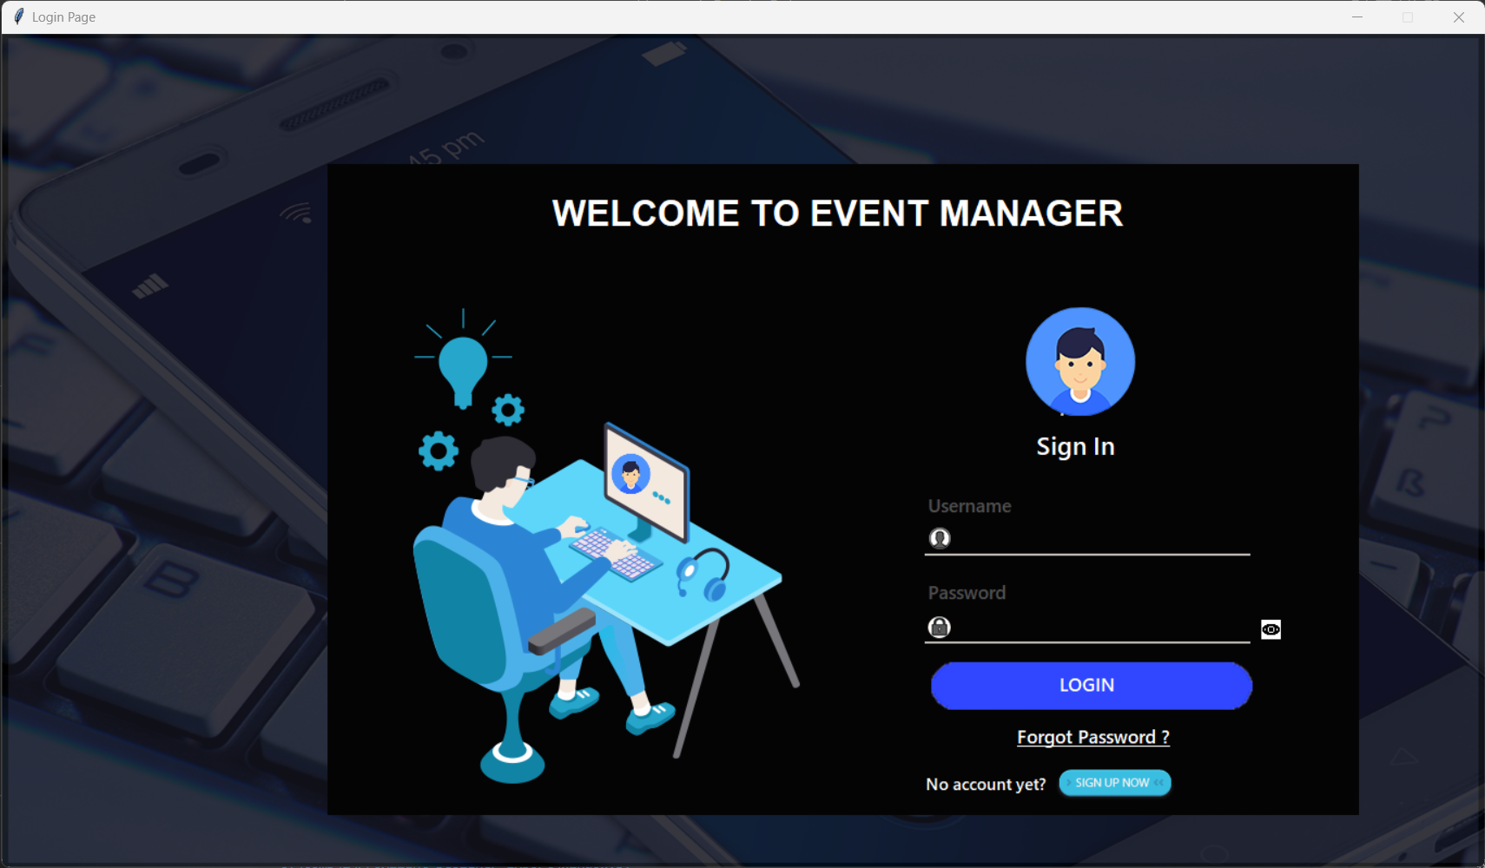

1. Sign up page to create a personal account:

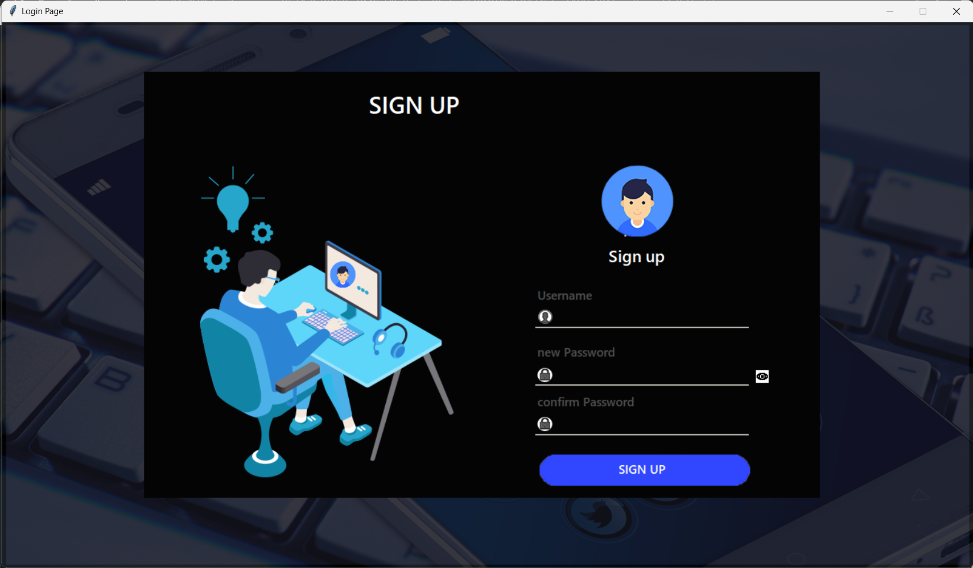

1. Personal Dashboard after Log in with event highlights, home button, settings, log out and calendar:



1. Event details of interested events you can register to: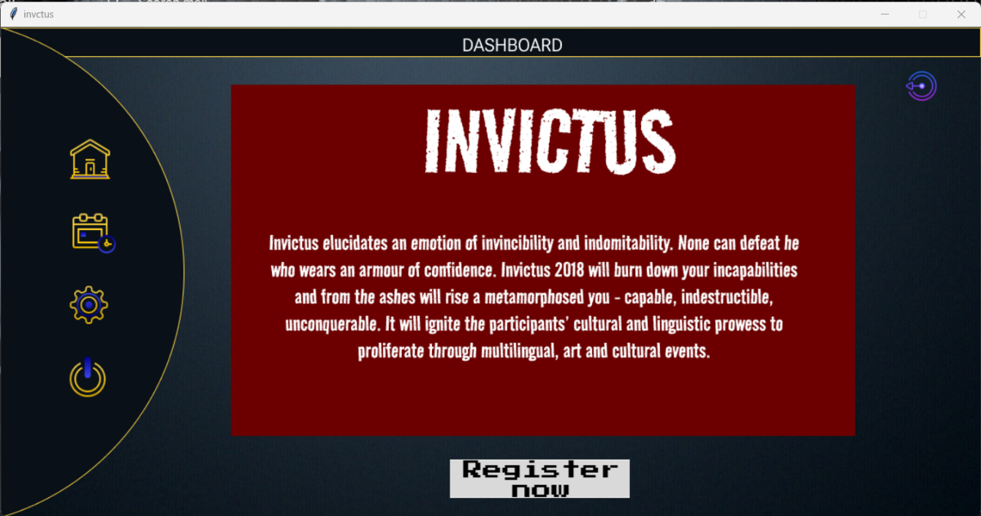
2. Registration page of particular chosen even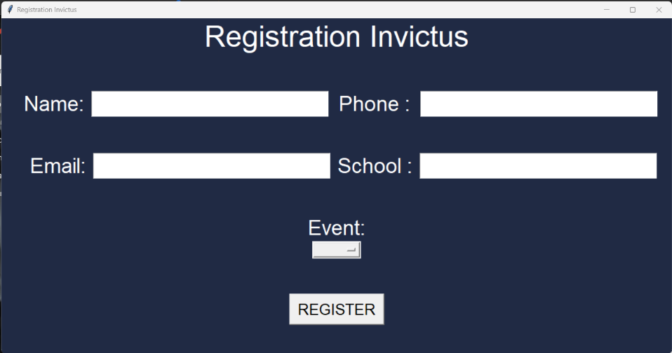
3. Page to check all events an individual has registered for:

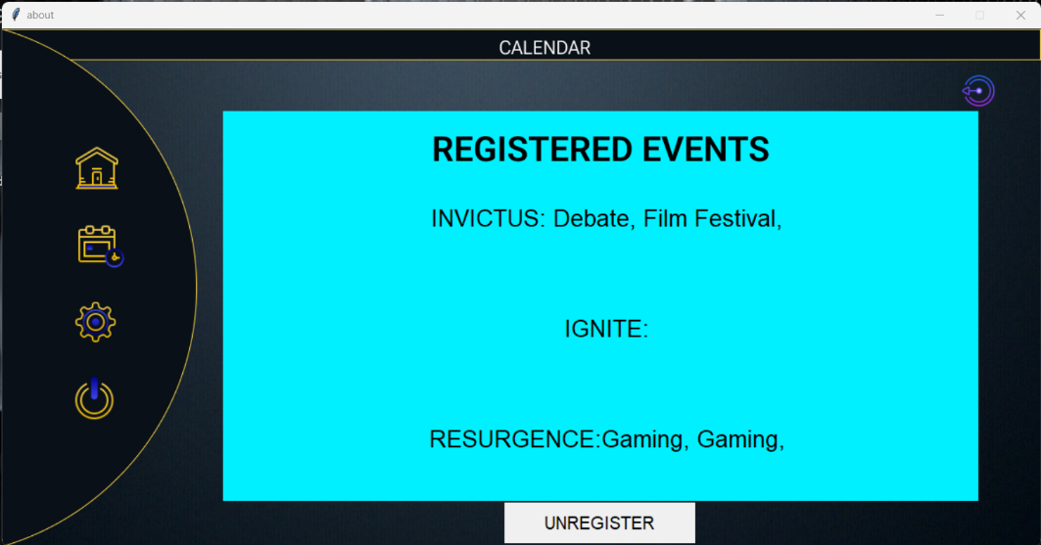

1. Unregistration page to unregister from any specific event:

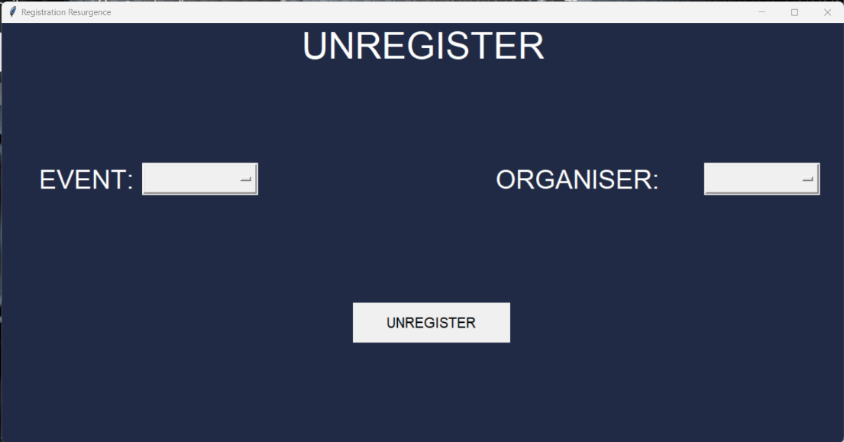

1. Settings page:

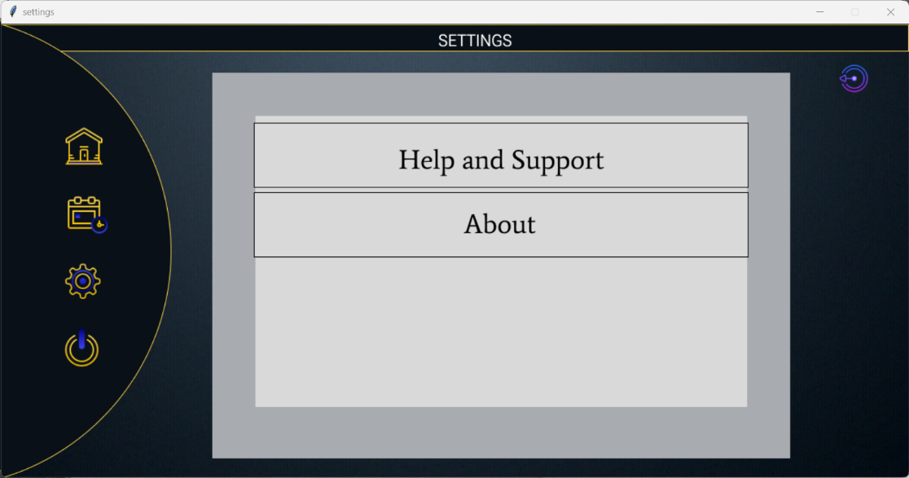

1. Help and support for contact:

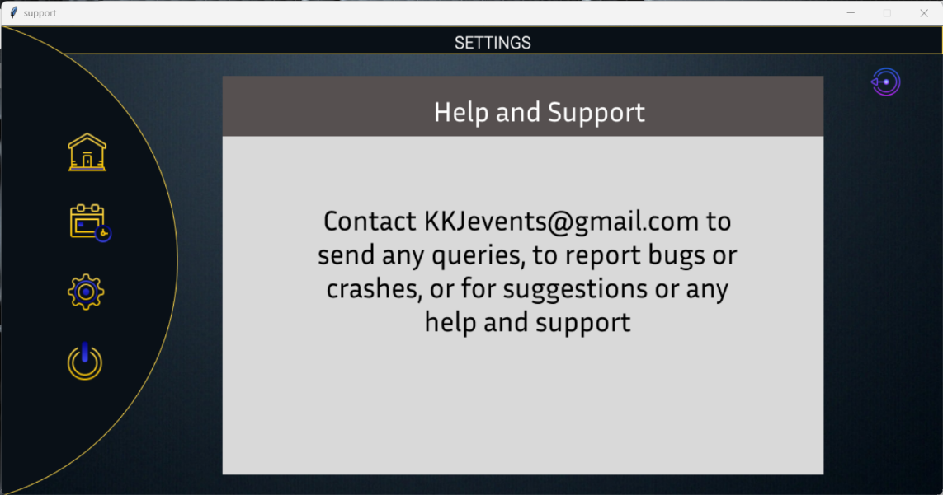

1. About overview:

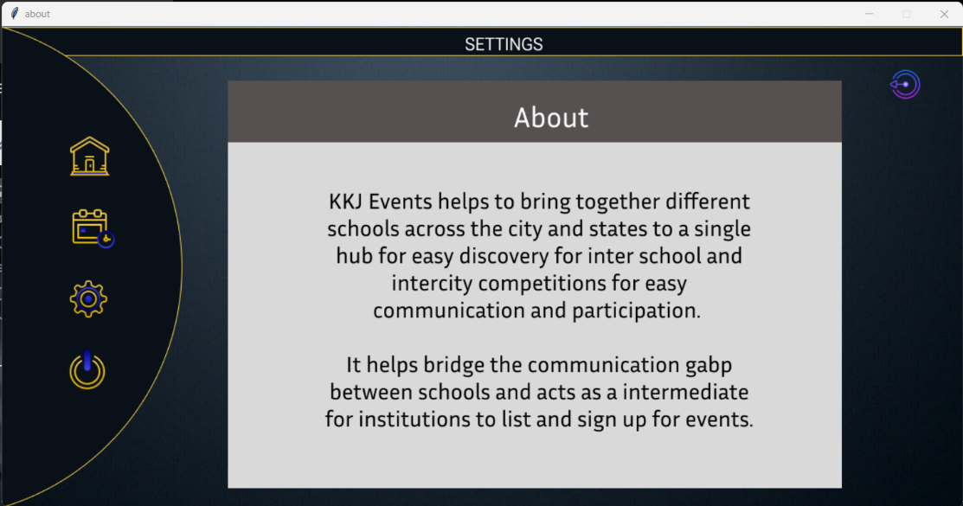

***BIBLIOGRAPHY:***

*SPECIAL THANKS TO-*

1. *CODEMY YT – helped in learning basics of tkinter and SQL.*
2. *KEITH GALLI – tkinter GUI basics*
3. *Figma.com*
4. *tutorialspoint.com*